SIMATS ENGINEERING (SAVEETHA SCHOOL OF ENGINEERING)
Department of Computer Science and Engineering
ASSESSMENT TOOL 1 – Coding Challenge Task
Course Code: | CSA06 | Course Title: | Design and Analysis of Algorithms
CO Assessed: | CO4: Articulation (BL4, BL5) | Assessment: | Assessment Tool 1 – Coding Challenge Task
Weightage: | 40% of CIA | Total Marks: | 100 (2 Questions × 50 Marks)
CO4 Statement: | Solve optimization problems using dynamic programming and greedy strategies.
Student Name: | A M RAKESH | Reg. No.: | 192424393
Section / Batch: | AIDS/24 | Date: | 21/08/2026

Instructions to Students
- Answer both questions. Each question carries 50 Marks. Total: 100 Marks.
- Carefully analyze the given questions.
- Write clear code for the given problem.
- Analyze the Time complexity and Space complexity of your code using dynamic programming and greedy strategies

Question Type | Description | Questions | Total Marks
Coding Challenge Task | Focus on Code and analyze optimization problems using dynamic programming and greedy strategies | Q1 – Q2 | 100
RUBRICS FOR CALCULATION
Coding Challenge Task

Criteria | Weightage | Level 4 (Exemplary) | Level 3 (Proficient) | Level 2 (Developing) | Level 1 (Beginning)
Problem Understanding | 20% | Clearly understands problem constraints, edge cases, and competitive requirements | Understands problem with minor gaps in constraints | Partial understanding; misses key constraints | Misinterprets problem or constraints
Algorithm | 25% | Selects optimal algorithm with best time and space complexity for competitive constraints | Uses efficient algorithm with minor scope for improvement | Uses basic/inefficient approach | No clear algorithmic approach
Code Implementation | 20% | Writes correct, efficient, and clean code that passes all constraints | Code works with minor errors or inefficiencies | Partially correct code; fails for some cases | Code does not execute or gives incorrect results
Competitive Performance | 20% | Solves problem within time limits and handles large inputs effectively | Solves within acceptable time with minor delays | Struggles with time limits or larger inputs | Unable to solve within time constraints
Test Case Handling | 15% | Handles all test cases including edge and hidden cases | Handles most test cases | Misses important edge cases | Fails on multiple test cases

SECTION A – Coding Challenge Task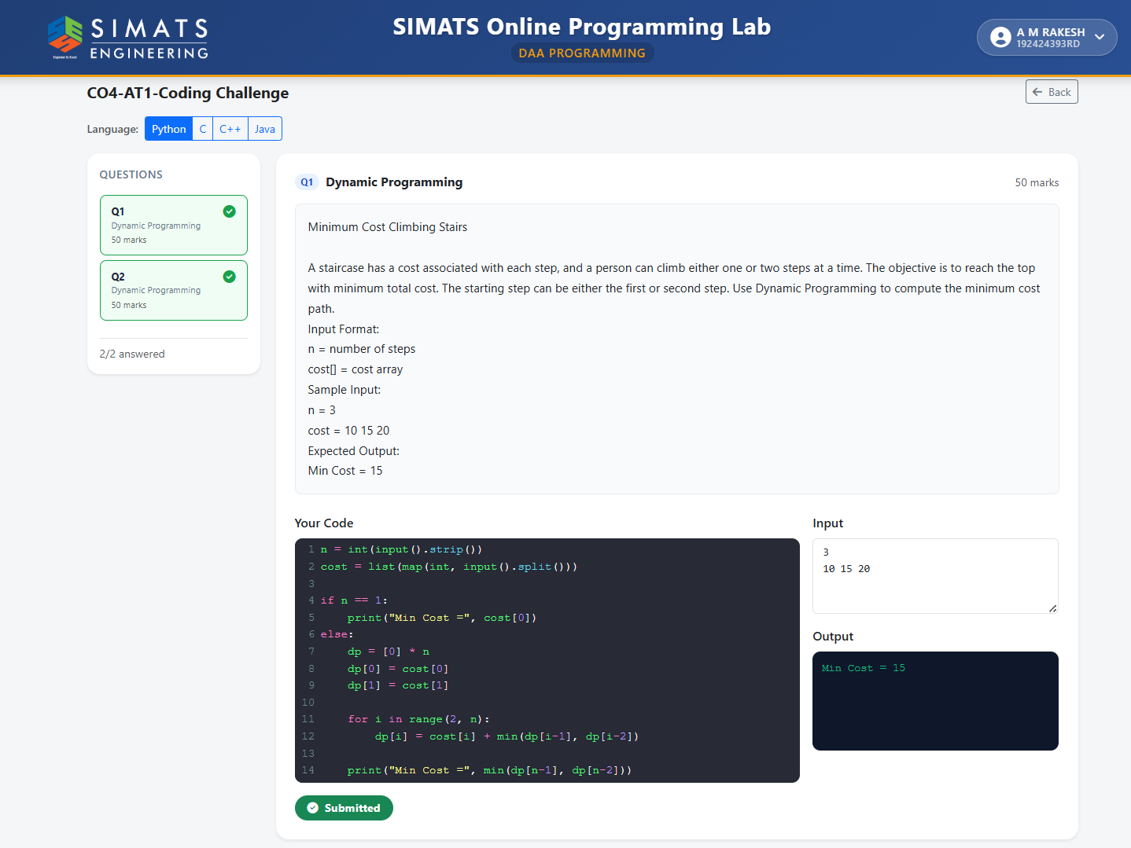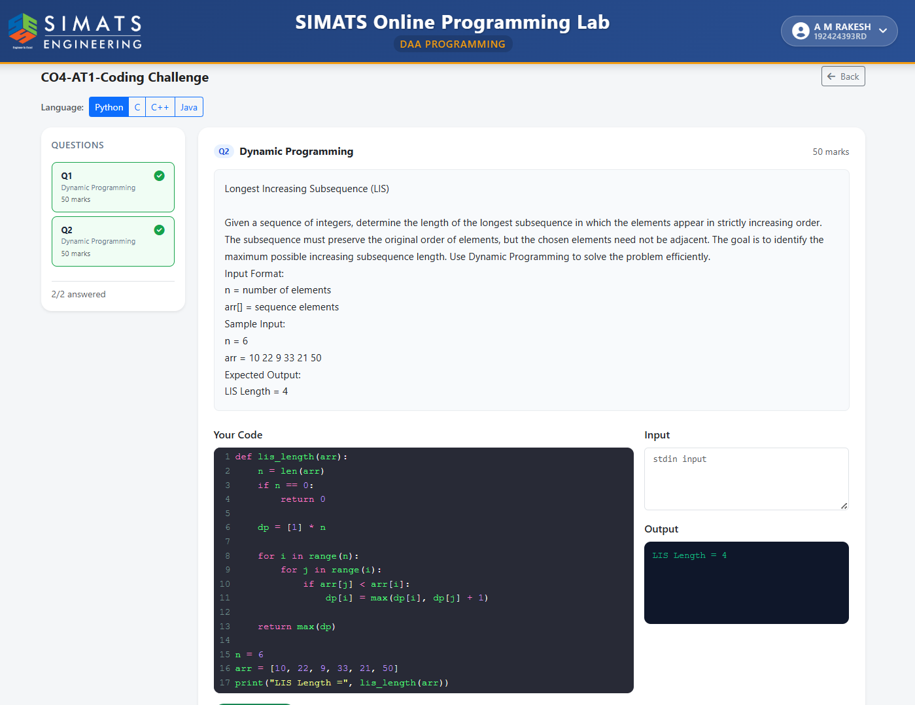

Code of Conduct
I A M RAKESH/192424393 (Name / Reg No) certify that this submission is my original work and that I have adhered to the guidelines specified for this assessment. I understand that any violation of academic integrity rules will result in disciplinary action.
Signature of the Student: 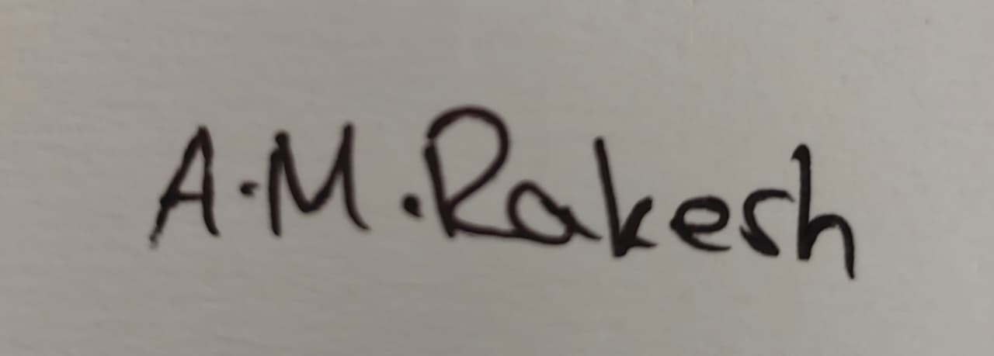

Mark Evaluation:
Questions | Problem Understanding (20) | Algorithm (25) | Code Implementation  (20) | Competitive Performance  (20) | Test Case Handling  (15) | Total Marks  (Each - 50)
Q1
Q2
Overall Total

Faculty In-charge | Course Coordinator | Head of Department
Name: __________________  Signature: _______________ | Signature: _______________ | Signature: _______________
Date: ___________________ | Date: ___________________ | Date: ___________________

